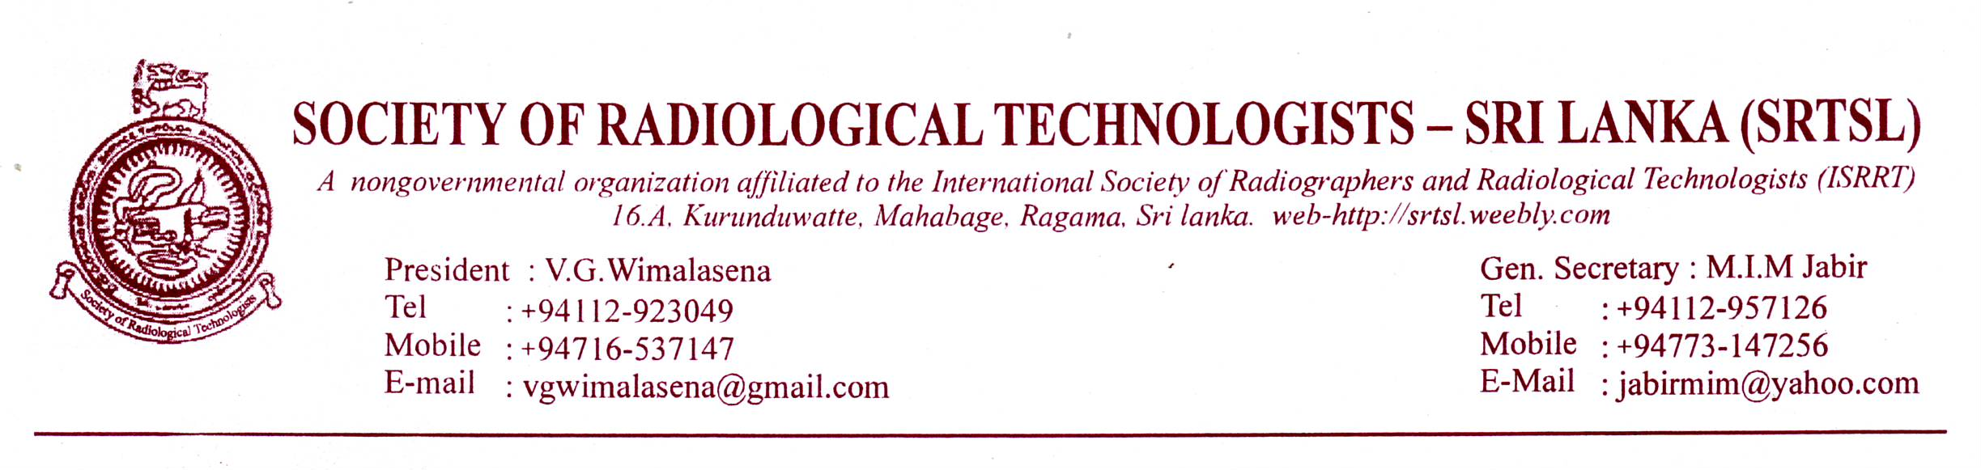
21st of May , 2014
News letter No: 5
Dear Colleague:
As the AGM of the Society of Radiological Technologists Sri Lanka is nearing we would like to keep our members updated with latest information.
First of all let me make a correction to the last news letter which was issued in March/ April this year.
In that news letter the date of the AGM is printed as 28/6/2014 and we apologize for that mistake. The correct date of the AGM is 29th of June, Sunday, 2014. From 9.00AM -4.00PM.
The Venue is : Postal Department Auditorium, D.R.Wijewardene Mawatha, Colombo. 10.(Lake House Road)
The days program will be:
From 9.30 AM – 1.00 PM workshop by Mr. Mohan Palliyaguru on “Personal Development and
Motivation”
1.00PM- 2.00 PM: Lunch
2.00PM- 4.00PM AGM
Detailed Agenda is appearing in the last page.

CT Diploma Program :
We are receiving applications from members. There is a constant enthusiasm among members about the Diploma program. So far we have received more than 50 applications and we will be able to accommodate all the applicants. Applications will be closed on 15th of June.
As usual the Fee for the Diploma course will be Rs: 20.000/=
The selected applicants will be notified and if willing to participate in the program the applicant has to deposit the amount in favour of
SRTSL Account No: 1840508 Bank Of Ceylon Branch ,Regent Street Colombo-10. And send the Bank Slip/ or the Photo Copy of the Slip to Miss. Kusum Edirisuriya the Treasurer of SRTSL, NHSL, Colombo. A receipt will be issued for your payment by the treasurer.
The Diploma course will start from 3rd of August. Sunday and lectures will be held on every other Sunday. Lecture schedule will be given on the inauguration day.

Change of Web Address of the Society:
Members please note that the new website number for the Society will be : WWW.SRTSL.COM
Workshop for Radiological Technologists at the annual scientific sessions of the Sri Lanka College of Radiologists:
There will be a parallel workshop for Radiological Technologists conducted, in par with their annual scientific sessions, by the College of Radiologists on 31st of August 2014. Still there is no official notice. Be on the watch out.
Allied Health Science program: Student Agitation for 4 year program.
The SRTSL is fully supportive of the student agitation to restore the 4 year program for allied health science. The SRTSL will participate In any forum supportive of this program.
“T” shirts.
The Society decided to produce T shirts as a memorabilia to be sold to members during the
AGM session. The T shirts will contain SRTSL logo and will be priced at Rs.1000/= each. Will be made available in three sizes. Large. XL, XXL. Only a limited edition will be available and make sure you get yours In time.

Private sector members: who wish to participate in the AGM please make sure that you pay the annual contribution at the registration counter. The annual member ship fee is Rs: 500/- per year and if you have paid the contribution at any events between 2013 June up to now it is not necessary to pay it again.

President visits for Helsinki – Finland ISRRT session:
President of SRTSL will attend ISRRT world congress 2014 to be held In Helsinki, Finland during June 8th to June 15th. The ISRRT program is available in ISRRT web site. We wish the president Bon Voyage.

The magazine “ Radiographer”:
The Magazine of the SRTSL will be published and distributed among members during the world Radiography day sessions in November . Members are kindly requested to send their articles, research papers etc before 15th of Sep. 2014 to the Editor. Soft copies are welcome. They should be sent to vgwimalasena@gmail.com .

The Agenda of the Annual General Meeting is attached.
Dear members your presence is highly solicited for this annual event. The society is one of the most valuable assets we have and lets us forge together for the betterment of the society. Long live SRTSL.
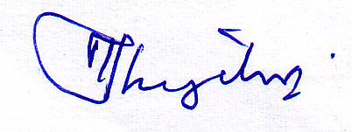
M.I.M. JABIR
General Secretary.

SOCIETY OF RADIOLOGICAL TECHNOLOGISTS- SRI LANKA
ANNUAL GENERAL MEETING
29TH OF JUNE 2014

DATE: 29TH OF JUNE 2014
TIME: 9.00 AM – 04 PM
VENUE: POSTAL DEPARTMENT AUDITORIUM
D.R. WIJEWARDENE MAWATHA – COLOMBO-10
AGENDA:
9.00 – 9.15. REGISTRATION
9.15 – 9.30 LIGHTING OF OIL LAMP
NATIONAL ANTHEM
A MINUTES SILENCE PRAYER FOR DECEASED.
9.30 –10.15 FIRST SESSION OF WORKSHOP BY Mr. MOHAN PALLIYAGURU
10.15—10.30- TEA
10.30—1.00 PM SECOND SESION OF WORKSHOP
1.00 PM—2.00PM LUNCH
2.00 PM—4.00PM AGM SESSION.
Welcome speech by president
Reading of the minutes of the previous AGM and adoption.
Matters arising out of minutes.
Adoption of accounts.
Presentation of Annual report by secretary
Election of new Council members.
Any other matters.
Conclusion.
Tea.
………………………………………………………………………………………………………………………………………………….
Consent Form (For Attending AGM)
Please send /hand over this form to the secretary/any council member of SRTSL before 15th June 2014
Name :
Address:
Telephone Number:
Email Address:
I here by consent to participate in the AGM of the SRTSL. 2014.

Signature
Date:

