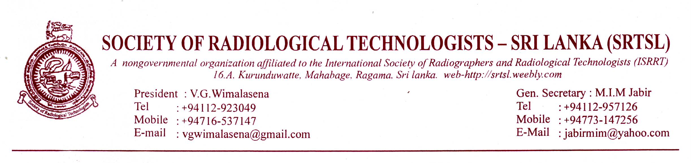
21.03.2014
NEWS LETTER No: 4/2014
Dear colleagues
We are pleased to address you after a hectic period of activities. The months of preparation for the CR & DR workshop ended very successfully and the panel of lecturers and all the participants were very happy. This is one of the most informative and productive workshop we ever had for some time now.
The Society had been announcing the preparation of the workshop from last April 2013 and the response from the membership was overwhelming. We feel sorry we could not accommodate all who wished to participate. Please keep in touch and may be we will be able look for further opportunities in the future.
The Society is highly grateful for the ISSRT for offering us this opportunity and sending us the necessary funds and personnel. Also we are very thankful for the lecturing panel Prof. Ms. Maria law, Professor Napapong, Professor Anthony and Mr. Edward for optimum contribution in their part. The panel was very pleased the way we conducted the workshop.
Also we are very thankful for the Director and the staff of Central Hospital, Mr. Weerakkody for organizing the auditorium food etc. and all our council members Mr. jawana ,Mr. jayasiri, Treasurer Miss. Kusum Edirisuriya, and Mr. Hiran Senanayake who arranged transportation and hotel bookings etc and Mr. Suraweera, Mr. Udayanga and Mr. Ilankoon. It is our total commitment that made this event a success.
AGM: 2014:
The Society is planning to hold its AGM for this year on 29th of June 2014. At the Postal Dept head office auditorium at Wijewardene Mawatha Coombo-1.
The Scientific session of the morning session will be a workshop conducted by eminent personnel in “personal Development” The postal dept. auditorium was selected for this purpose. Members are advised to register themselves as early as possible by sending the consent form filled which appears along with this news letter.
T- SHIRTS:
The national council made a decision to make some T- shirts with society logo and name on it for sale during the AGM session. A T-Shirt may cost from Rs.800.00 to Rs. 1200.00. Around 100 T-shirts will be on offer and members will be able to purchase them during the session.
DIPLOMA IN CT PROGRAM:
Diploma in CT program will be initiated for the 4th time and the date is not yet decided. However the council decided to call for applications and a form is appearing along with this news letter. This may be the last opportunity for members who are willing to take part in this program and after this the field may shift to another program.
The terms and conditions will be same as our previous programs and we will notify in the immediate future.
“Radiographer”
The Society magazine Radiographer will be issued along with the World radiography day Celebrations. Members are asked to submit their articles forth with.
Member subscriptions:
The society is receiving its life line as subscription from our dear members. When we took over the society about 4 years back we did not have funds even to hold an annual general meeting. With the unstinting support from our members to day we are in a stronger position. Our annual subscription is Rs.500/=. It will work out to be around Rs.40/= a month. Not a big sum. We can only buy two wraps of beatle leaves or two plain teas with that money, Please consider it as being given on charity. So when GRTA treasurer deducts this amount please give a supporting hand. We need the Society to keep our profession above the level of water. So again and again we appeal our members to support the society. If you are not participating in any event conducted by the society it is your choice. But you are welcome for any occasion. Also your contribution is not lost. The society will issue a magazine copy “Radiographer” on your behalf. Which is worth more than Rs.500/=. So please have a heart.
Finally I thank again for the cooperation extended by the members and let us unite together to keep the society alive. Long Live the SRTSL.
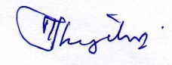
M.I.M.jabir
General Secretary
SRTSL

APPLICATION FOR CT DIPLOMA PROGRAM 2014
- Name in Full:
- Name with initials:
- Address: Home:

Office:

- Telephone Number: Home: Mobile
Office
- Workstation:
- Email address:
- First date of appointment:
- Society membership No:
- Any experience In CT:
- Closest CT work station:

I hereby agree to the rules and regulations applicable and agree to pay the stipulated sum before the initiation of the course.

Signature of the applicant: Date:
NIC Number

Consent Form (For Attending AGM)
Name :
Address:
Telephone Number:
Email Address:
I hereby consent to participate in the AGM of the SRTSL. 2014.

Signature
Date:

