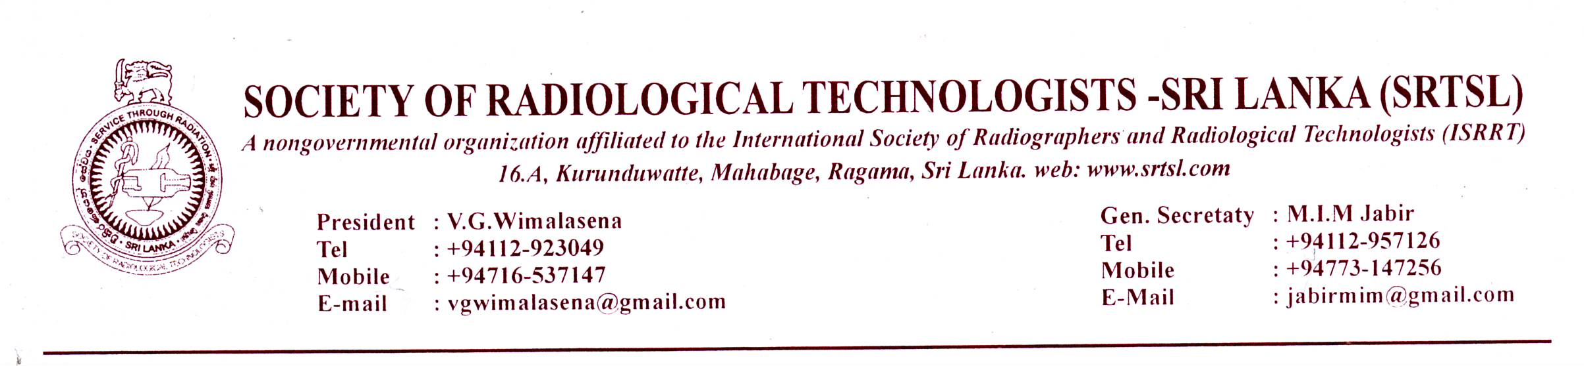
28/09/2016
News Letter – 2 (2016-17)
Dear Colleagues,
It’s a pleasure to write you again to inform you about the latest in Society news.
The “World Radiography Day” program is on the schedule and to facilitate the members it will be conducted on 6th of Nov. 2016
Venue : Hotel Ramada . Near Gall Face Green.
Registration starts at 8.30 AM exactly.
Pre-registration
Members please make sure that you pre- register for the event in time. About 120 participants could be accommodated and register yourself early and avoid disappointments.
Registration fee is Rs: 1000/= ( consider escalation in prices )
Members are kindly requested to send their consent forms along with a copy of the bank slip for payments of registration fee. Society A/C number is 1840508 BOC , Regent street branch.
The consent forms shall be sent/handed over to the General secretary, Principal School of Radiography or the Treasurer. Bank slip is a must for registration. The Consent forms and bank slips must reach us before 1st of November 2016.
The private sector members have to pay their annual subscription along with the registration fee. Annual subscription is Rs: 500/=. If you have paid your subscription already no need to pay it again.
The Magazine :
The Magazine Radiographer will be launched during the event. Members are requested to send their articles before 15th of October to the principle School of radiography. A soft copy is welcome. Members can write articles on any subject related to medicine.
The agenda for the occasion is attached.
Poster campaign.
Members are requested to organize a poster campaign in their work places on 8th of November 2016 the day WRD falls. The titles are available in the ISRRT website.

THE SOCIETY OF RADIOLOGICAL TECHNOLOGISTS SRI LANKA.
THE WORLD RADIOGRAPHY DAY CELEBRATIONS 2016
Theme: “ Quality control : Radiological Technologist plays a major role”
Date:- Sunday 6th November 2016
Venue: Hotel Ramada Colombo, 30, Sir Mohamed Macan marker Mawatha, Colombo-03
THE AGENDA
9.00 AM - Lighting of oil lamp & National Anthem
Welcome speech by the president
9.30 AM “Clinician’s perspective of a chest X-ray”- Dr. Mrs. Ravini De Silva Karunathilake,
Chest Physician.
10.20 AM Launching of “Radiographer” Magazine
10.30 AM TEA
11.15 AM “Role of Radiotherapy in modern cancer management” ” - Dr. Prasad
Abeysinghe. Consultant Oncologist, Apeksha Hospital, Maharagama
12.15 PM Message from sponsors.
12. 45 PM ” Interventional Radiology & contrast media” - Dr. Mohan Rajakaruna
Consultant Cardiologist, Nawaloka Hospital
1.45 PM CONCLUSION Vote of thanks
2.00 PM LUNCH

Members are kindly requested to be on time for the occasion.
For further information we will be keeping in touch with you. Also can contact me or the president on above phone numbers.
Long live SRTSL.
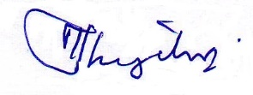
M.I.M. Jabir
General Secretary , SRTSL,

Consent Form
THE SOCIETY OF RADIOLOGICAL TECHNOLOGISTS SRI LANKA.
THE WORLD RADIOGRAPHY DAY CELEBRATIONS 2016

Name :
Working Station:
SLMC registration Number: SRTSL membership No:
Payment made = Rs. …………………………. (Please attach the bank slip)

Signature:- Date:-

(Registration fee is Rs: 1000/=
Members are kindly requested to send their consent forms along with a copy of the bank slip for payments of registration fee. Society A/C number is 1840508 BOC , Regent street branch.)

