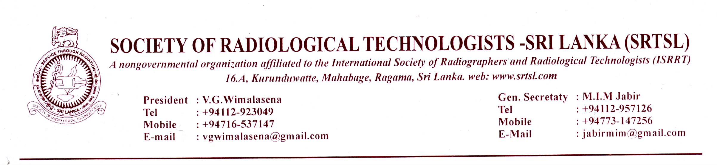
News letter No: 3 of 2015/ 2016

8th of April . 2016
Dear colleagues,
We are very pleased to send you this newsletter with information regarding future activities of the Society.
We wish to highlight the fact why our profession is not booming where as other similar professions are taking wider strides forward is that our members lack enthusiasm in the development of our profession. We appeal to all our members to take keen interest in the activities of the Society and participate in events and put forward your proposals for the benefit of all.
World Radiography Day 2015 - Held:
As usual the world Radiography day was successfully held on 8th of November 2015 , Sunday at GRAND MONARCH HOTEL ( 4 STAR HOTEL)’ 527/7 BORELLA ROAD , THALAWATHUGODA.
We wish to thank all the members who participated and the management committee members and others who supported numerous ways to make it a success.

Proposed MRI COURSE:
The proposed MRI course preparations are being carried out by the society.
Course duration will be nearly 9 - 12 months. Course fee will be Rs. 30,000/- per candidate.
Course will be initiated soon after the AGM 2016.
Maximum participants will be : 25.
Applications are called for from the members who wish to take part. The specimen application is attached herewith. The closing date for applications is 31st May 2016

Radiation protection workshop conducted by the IAEA - Held on December 7th – 11th 2015
Though it was mentioned in the previous news letter, the society was not in a position to take the responsibility to hold it according to the prescribed terms and conditions. Therefore The workshop was conducted by the organizers themselves with the participation of some radiographers in NHSL from December 7th – 11th 2015.

Proposed Part Time Degree Course In Radiography At
General Sir John Kotalawala Defence University

The progression of this proposal is interrupted as the Dean of the faculty and the Vice chancellor of KDU is changed. We will have start it all over again.

Lateral entry to BSc Radiography programme at FAHS Peradeniya
Dr. Mohan jayathilake, Head of the department of radiography at FAHS, Peradeniya has informed that the University senate has approved the proposal to recruit a percentage of diploma holders to the current internal degree programme. He says that he is working on the process.

AGM 2016
The annual general meeting and the annual educational session is planned to be held on the last Sunday of June 2016. Keep the day free.
Please send your proposals regarding the educational session; topics. Lecturers etc.

Thank you.
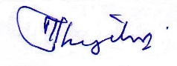
M.I.M.jabir
General Secretary

Application Form
MRI Training Course 2016
Conducted By The Society of Radiological Technologists Sri Lanka

Name (Mr/ Ms) : -

Age :-

Membership No:- (please refer to the membership list published in the society website.
Link: http://www.srtsl.com/membership.html )
Workstation :-

Address & contact detail :
(with Telephone numbers)

Date of first appointment:-

MRI experience :

CT experience / Qualification :

I hereby certify that the above particulars are true and I will abide the rules and regulations of the programme, if I am selected.

Signature: Date:

Address To be sent : - Mr. Jawana Dissanayake
No. 54/B/3
3rd Lane
Hansagiri Rd
Gampaha

