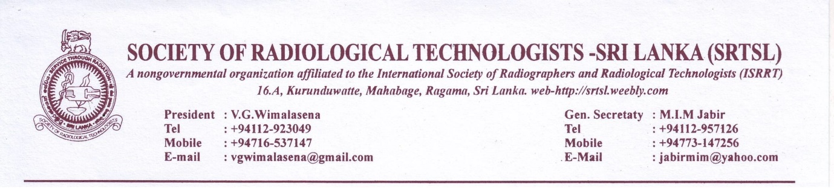
1st of May 2018
Newsletter No: 2/2018 SRTSL
Dear Colleagues
It’s a pleasure to address you once again to notify the Annual General Meeting for the year 2017/2018. This will be the 43rd annual general Meeting since the inception of the Society. In our previous newsletter we indicated that the AGM will be held in late June instead the National council decided to conduct the AGM on July 1st 2018. First of all we invite all the members to participate in the event. Other than the usual lectures and scientific session the major event will be awarding certificates for the participants and those who passed the final exam of the MRI course conducted by the SRTSL in the past year.
The certificates will be signed by the DDG ET&R and by Dr. Janaka P Wansapura and by Mr.V.G.Wimlasena as course coordinator.
The Directorate of the Education Training and Research of Ministry of Health evaluated the course contents and activities and decided to give an evaluation of 22 credit points for the course. Their opinion is that If it is to be Diploma course it should be 30 credit points. As we have no time in amending and continuing the course further we agreed to award a ADVANCED CERTIFICATE IN MRI as proposed by Director Education. As such the certificate will be an Advanced Certificate in MRI.
AS the SRTSL is planning to conduct the future courses in conjunction with DDG ET&R unit of MOH we will be having an opportunity to evaluate the course content before we go on training.
VENUE FOR AGM:
Venue for the AGM will be RENUKA HOTEL. at Gall Road Kollupitiya. We have booked for limited number of seats and please send your consents to attend the meeting on time. Consent information is attached in a separate form. Members are requested to send their proposals and suggestions 2 weeks before the AGM to the Secretary.
ANNUAL SUBSCRIPTION:
Members who are in Govt. service are automatically contributing annually and the private sector members are requested to pay their contribution to the treasurer or could paid at the entrance to the venue. Annual fee is 500/= per year. New members are required to pay an admission fee of Rs. 1000/= and the annual fee of Rs . 500/=. Members can also pay through the Society A/C No. 1840508 in BOC Regent Street Branch as well.

WORLD RADIOGRAPHY DAY CELEBRATIONS IN 2018 NOVEMBER:
The SRTSL is having a plan to conduct the WRD in an elaborate manner. So far we did not receive any response from general membership. Please note that the General Public should be made aware about who we are and a marketing process should be initiated. Please send your proposals.
MAGAZINE 2018 AND ADVERTISEMENTS:
The Magazine, Radiographer will be printed this year too and now itself we need to collect the articles and advertisements for the Magazine. Member s please take active part in collecting advertisements, especially from outstations. As for articles we receive mainly from undergraduates and we invite our permanent members to write whatever their experience and new initiatives and organizing new departments in your work place.
ISRRT WORLD CONGRESS IN TRINIDAD AND TOBAGO:
The World Congress of Radiography which was conducted by ISRRT in April 12-18 this year was in Trinidad and Tobago islands and Mr. V.G.Wimalasena attended the congress.
SRI LANKA’s bid to conduct the World congress in year 2022 was not successful. We made our efforts and gained some experience through it. We can make the same effort in the future. For 2022 Thailand was selected as venue for world congress.
PROPOSED FUTURE COURSES BY SOCIETY:
The SRTSL is planning to conduct courses in CT scanning and Nuclear Medicine leading to Diploma course during next year. This is being organize as there is a high demand from the membership.
I thank all our members for cooperating with the management and participation in the events during the year. We expect a little more dedication from the members for our own benefit. Let’s strive hard together to make our profession prosper.
Long Live SRTSL

M.I.M.Jabir.
General Secretary SRTSL.

CONSENT
To participate in the AGM & Academic session 2018
COULD BE sent by post to : Mr. M.I.M.Jabir,
( Secretary, Society of Radiological Technologists-Sri Lanka),
No 16 A. Kurunduwatta, Mahabage, Ragama
Or.
Could be sent by SMS to any one of the following Numbers:
Mr. V.G.Wimalasena, president. 0716537147.
Miss, Kusum Edirisuriya: Treasurer. 0714406648
Mr. M.I.M.jabir. Gen.Secretary. 0773147256
(Please send the following detail )
…………………………………………………………………………………………………………………………………………………..
CONSENT FORM:
To participate in the AGM & Academic session 2018

I give my consent to participate in the AGM and the annual academic session of the SRTSL -2018

Name:
SRTSL Membership No:
Workstation:
Telephone Number:
Signature:-

