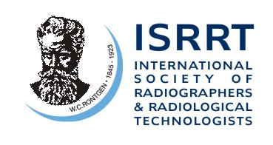…an international nongovernmental organisation in Official Relations with the World Health Organisation
Registered Office: 143 Bryn Pinwydden, Cardiff, CF23 7DG, Wales, United Kingdom
Tel. No. 44 (0)29 20735038 Fax No. 44 (0)29 540551 Email isrrt.yule@btinternet.com

11th February 2012

Dear Member and Council Members,

ISRRT Research Fund
Call for Grant Application
Application round in 2012
Theme: The Heart of Modern Medicine

The aim of the ISRRT Research Fund is to promote research that helps improve the standards of delivery and practice of medical imaging and radiation therapy. The ISRRT Research Fund was set up in 2009 and a research proposal was funded the first time in 2010.
On behalf of the ISRRT Board, Dr Maria Law, Chair Person of the Grant Committee, is inviting applications for a research grant for 2012.
With the advancement of technologies in imaging and radiotherapy there are unknowns in the modern technology for technologists to explore. Hence this year the ISRRT Board decided to set the theme for the 2012 research fund application as, “The Heart of Modern Medicine”. The successful applicant will have the opportunity to present their research results at the next World Congress in Helsinki in 2014. The duration of the project will therefore be 1 or 2 years and research proposals that meet this above target will be given priority.
The closing date for submission of grant application is 30 April, 2012 and the funding decision will be announced by the end of July 2012.
The total grant for 2012 is £5000, with £2500 for 1-year projects or £5000 for 2-year projects.
Full details of the Research Fund Guidelines and application form can be obtained by contacting isrrt.yule@btinternet.com and www.isrrt.org .
I would be grateful if you could distribute the invitation message to members of your societies.
Yours faithfully,
Dr Sandy Yule, OBE
CEO, ISRRT

